[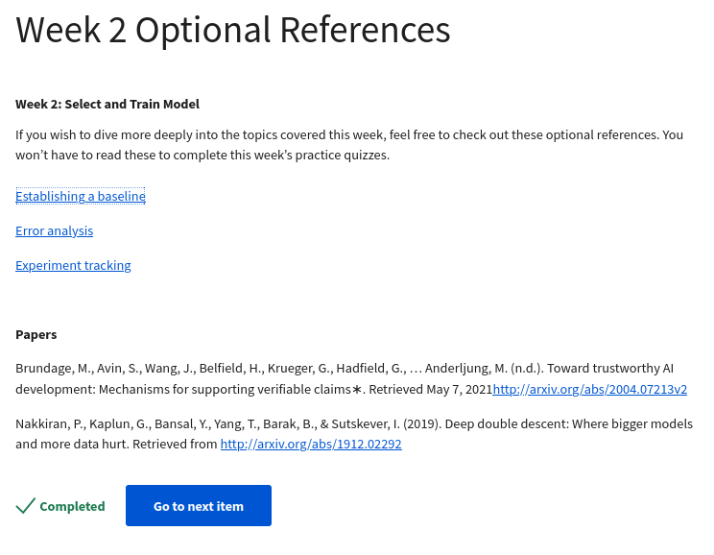https://neptune.ai/blog/ml-experiment-tracking](https://neptune.ai/blog/ml-experiment-tracking)

https://blog.ml.cmu.edu/2020/08/31/3-baselines/

https://techcommunity.microsoft.com/t5/ai-machine-learning-blog/responsible-machine-learning-with-error-analysis/ba-p/2141774

Papers

Brundage, M., Avin, S., Wang, J., Belfield, H., Krueger, G., Hadfield, G., … Anderljung, M. (n.d.). Toward trustworthy AI development: Mechanisms for supporting verifiable claims∗. Retrieved May 7, 2021<http://arxiv.org/abs/2004.07213v2>

Nakkiran, P., Kaplun, G., Bansal, Y., Yang, T., Barak, B., & Sutskever, I. (2019). Deep double descent: Where bigger models and more data hurt. Retrieved from <http://arxiv.org/abs/1912.02292>